Paraboloidal Solids of Revolution

Definition
# Source: AI Source: Provided by: [Data Path: Persons Table -> ID Column: 1, Name_En Column: Motasem Essam] -> From: [ChatGPT] on [7/25/2026]
A Paraboloidal Solid of Revolution is a three-dimensional solid generated by rotating a parabolic plane region around an axis of symmetry (the axis of the parabola).
The resulting solid is a circular paraboloid, also called a solid paraboloid.
A paraboloidal solid has:
- A vertex, which is the point where the paraboloid begins.
- An axis of revolution passing through the vertex.
- A circular base or circular cross-sections perpendicular to its axis.
- A curved paraboloidal surface.
- A volume enclosed by the curved surface and, when bounded, a plane base.
Important distinction:
- Rotating a filled parabolic region generates a solid paraboloid.
- Rotating a parabolic curve generates only the paraboloidal surface.

Geometric Representation
# Source: AI Source: Provided by: [Data Path: Persons Table -> ID Column: 1, Name_En Column: Motasem Essam] -> From: [ChatGPT] on [7/25/2026]
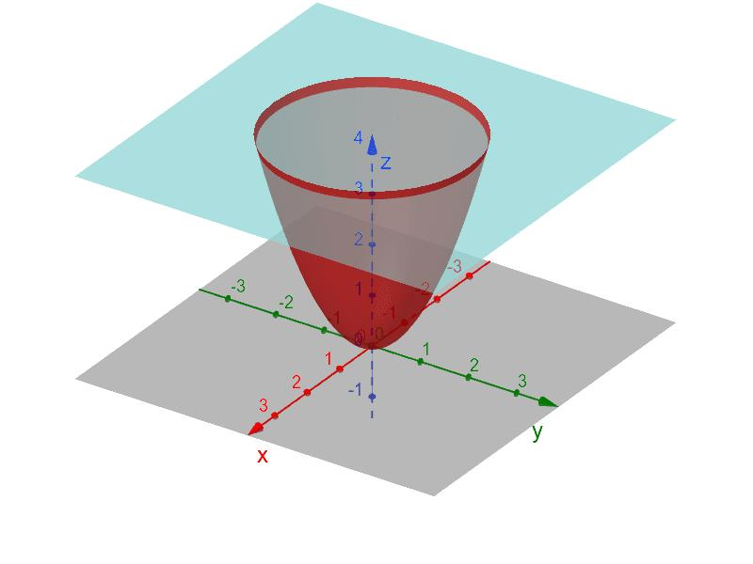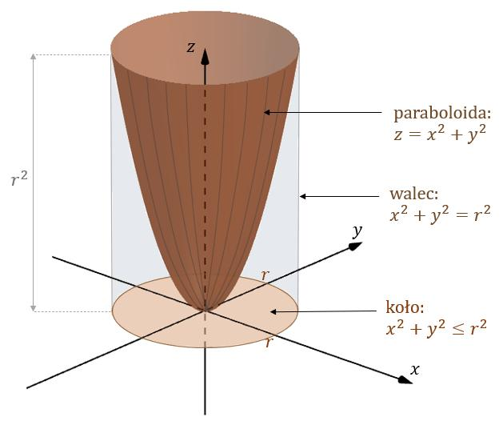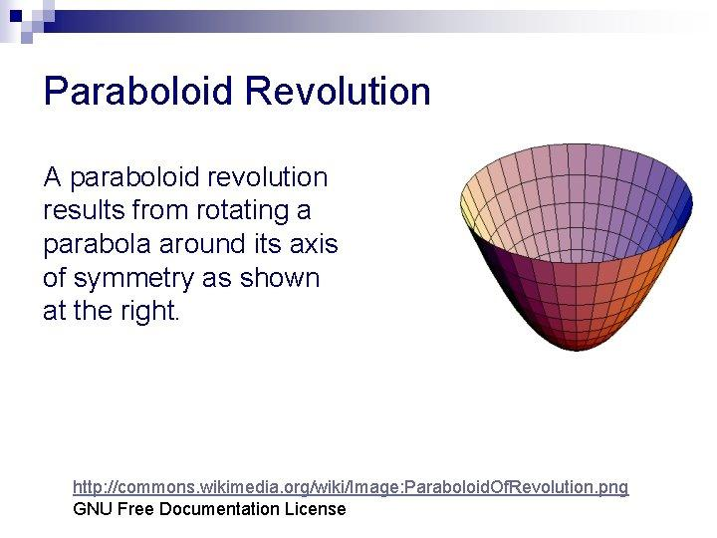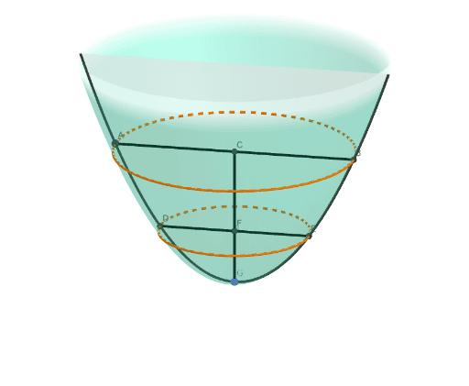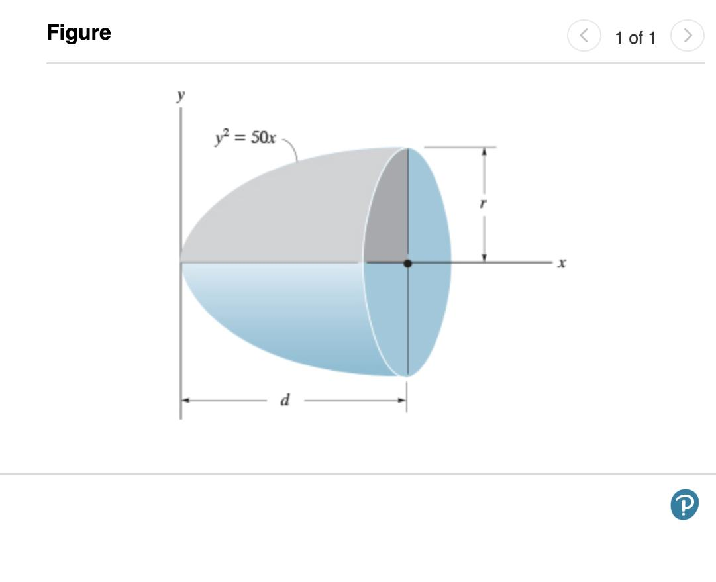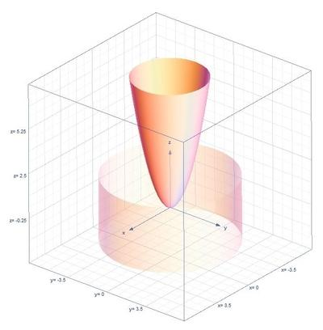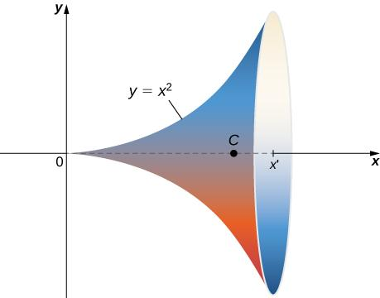

Geometric Structure
# Source: AI Source: Provided by: [Data Path: Persons Table -> ID Column: 1, Name_En Column: Motasem Essam] -> From: [ChatGPT] on [7/25/2026]
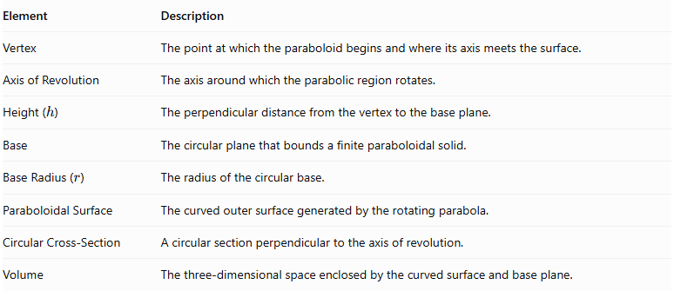
Element | Description
Vertex | The point at which the paraboloid begins and where its axis meets the surface.
Axis of Revolution | The axis around which the parabolic region rotates.
Height ($h$) | The perpendicular distance from the vertex to the base plane.
Base | The circular plane that bounds a finite paraboloidal solid.
Base Radius ($r$) | The radius of the circular base.
Paraboloidal Surface | The curved outer surface generated by the rotating parabola.
Circular Cross-Section | A circular section perpendicular to the axis of revolution.
Volume | The three-dimensional space enclosed by the curved surface and base plane.

Types of Paraboloidal Solids of Revolution

Right Circular Paraboloid
# Source: AI Source: Provided by: [Data Path: Persons Table -> ID Column: 1, Name_En Column: Motasem Essam] -> From: [ChatGPT] on [7/25/2026]
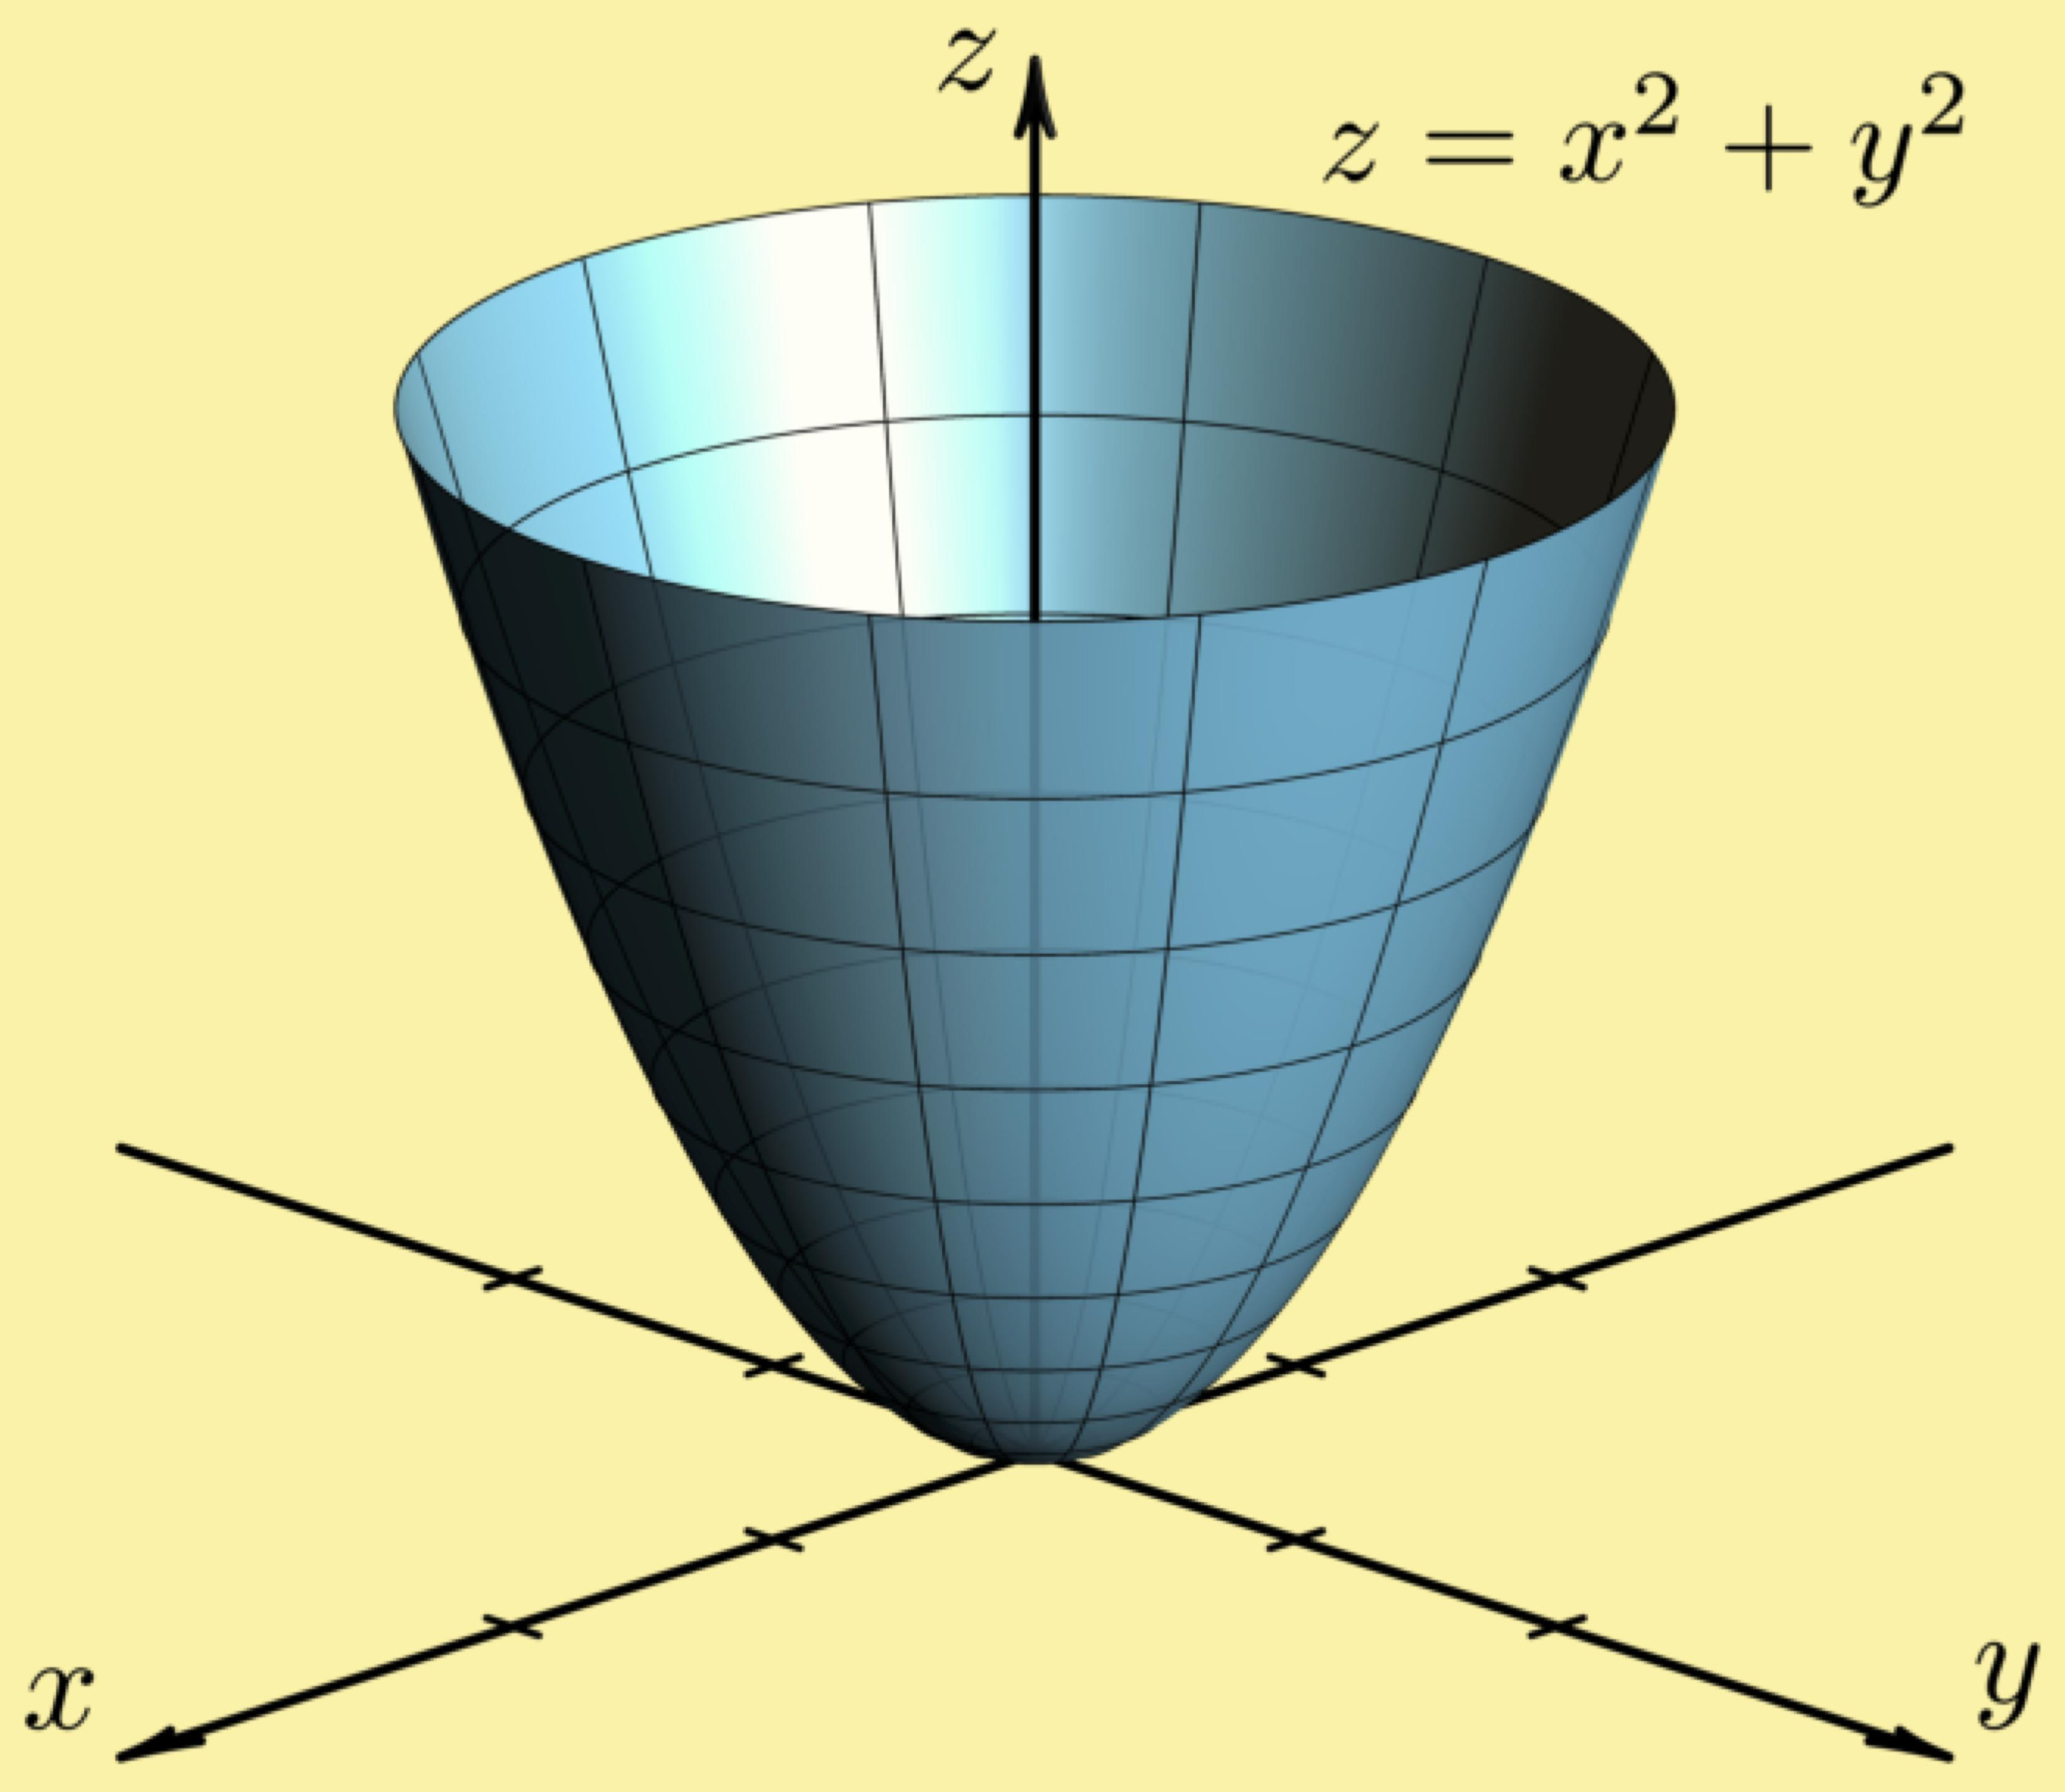
A Right Circular Paraboloid is generated by rotating a parabolic region around its axis of symmetry, with the axis perpendicular to its circular base.
Characteristics:
- Has a circular base.
- Has a straight axis of symmetry perpendicular to the base.
- Its cross-sections perpendicular to the axis are circles.
- Its axial cross-sections are parabolas.

Paraboloidal Segment
# Source: AI Source: Provided by: [Data Path: Persons Table -> ID Column: 1, Name_En Column: Motasem Essam] -> From: [ChatGPT] on [7/25/2026]
A Paraboloidal Segment is the finite portion of a paraboloid enclosed between its vertex and a plane perpendicular to its axis.
It is the common bounded form used when calculating the volume of a paraboloidal solid.
Characteristics:
- Has one vertex.
- Has one circular base.
- Has a curved paraboloidal lateral surface.
- Has a finite height and volume.

Hollow Paraboloidal Solid
# Source: AI Source: Provided by: [Data Path: Persons Table -> ID Column: 1, Name_En Column: Motasem Essam] -> From: [ChatGPT] on [7/25/2026]
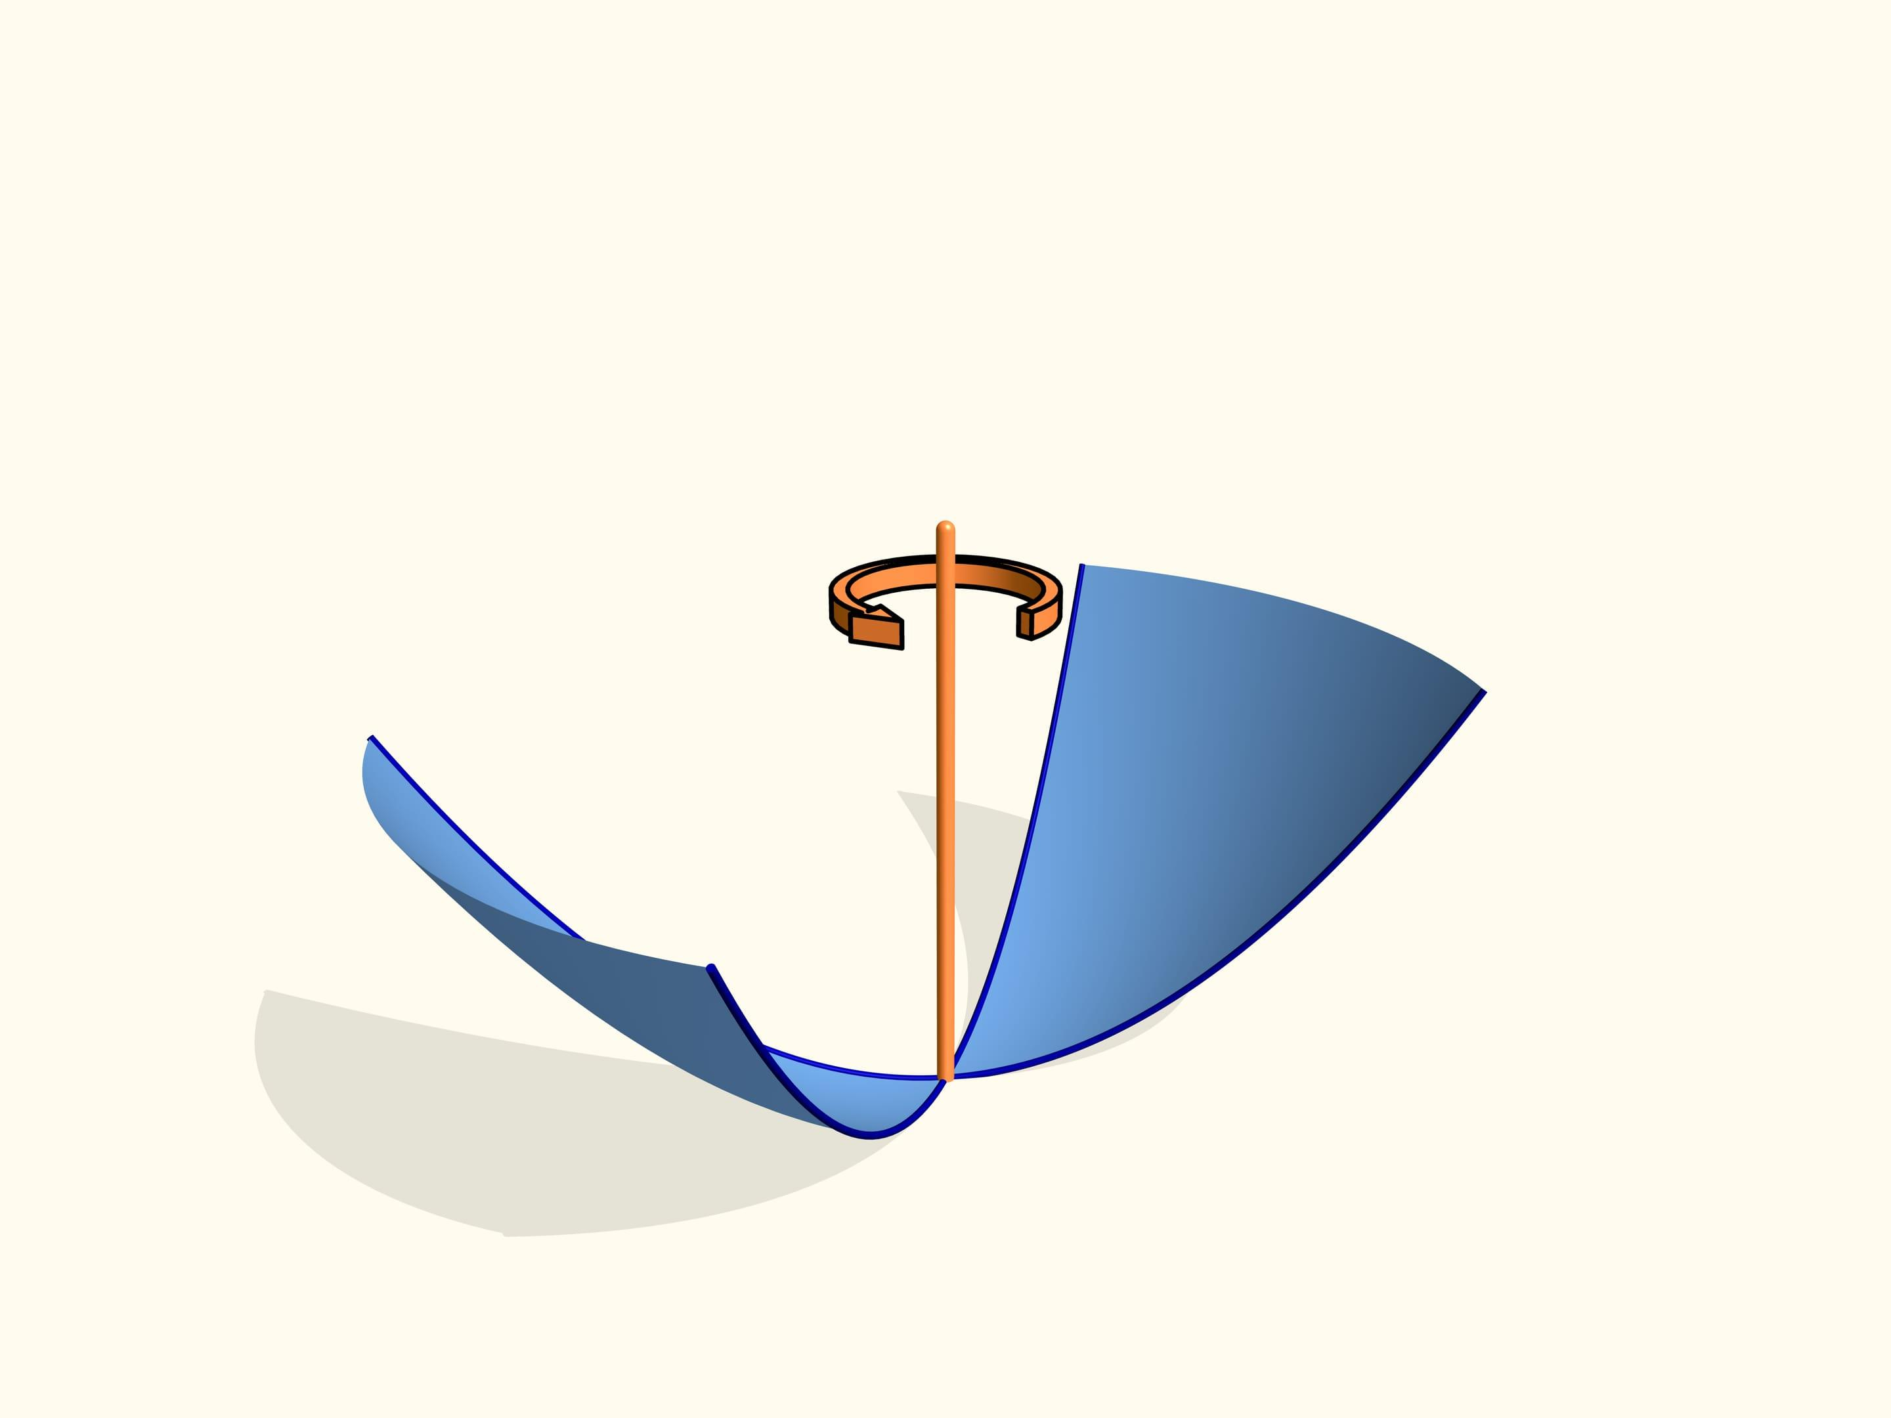
A Hollow Paraboloidal Solid is a shell-shaped form with a paraboloidal inner surface and an outer surface, separated by a wall thickness.
It can be modeled by two coaxial paraboloidal surfaces.
Characteristics:
- Has an inner paraboloidal surface.
- Has an outer paraboloidal surface.
- Has a wall thickness.
- May have an open or closed base.
Note: The hollow form is a shell construction rather than a different fundamental surface of revolution.

Mathematical Representation

Standard Equation
# Source: AI Source: Provided by: [Data Path: Persons Table -> ID Column: 1, Name_En Column: Motasem Essam] -> From: [ChatGPT] on [7/25/2026]
A circular paraboloid with its vertex at the origin and its axis along the positive $z$-axis is represented by:
$$z=\frac{x^{2}+y^{2}}{4f}$$
Where:
- $f$ = focal length of the generating parabola.
- $x,y$ = coordinates perpendicular to the axis.
- $z$ = distance along the axis.
Using radial distance:
$$ρ=\sqrt{x^{2}+y^{2}}$$
The equation becomes:
$$z=\frac{ρ^{2}}{4f}$$

Equation Using Base Radius and Height
# Source: AI Source: Provided by: [Data Path: Persons Table -> ID Column: 1, Name_En Column: Motasem Essam] -> From: [ChatGPT] on [7/25/2026]
For a finite paraboloidal segment with base radius $r$ and height $h$:
$$z=\frac{h}{r^{2}}(x^{2}+y^{2})$$
Where:
- $r$ = base radius.
- $h$ = height.
- $z$ = vertical distance from the vertex.
At the base:
$$x^{2}+y^{2}=r^{2}, z=h$$

Volume
# Source: AI Source: Provided by: [Data Path: Persons Table -> ID Column: 1, Name_En Column: Motasem Essam] -> From: [ChatGPT] on [7/25/2026]
The volume of a paraboloidal segment is:
$$\boxed{V=\frac{1}{2}πr^{2}h}$$
It is exactly half the volume of a cylinder with the same base radius and height.

Lateral Surface Area
# Source: AI Source: Provided by: [Data Path: Persons Table -> ID Column: 1, Name_En Column: Motasem Essam] -> From: [ChatGPT] on [7/25/2026]
The curved lateral surface area is:
$$A_{L}=\frac{πr}{6h^{2}}\left[(r^{2}+4h^{2})^{3/2}-r^{3}\right]$$
The total surface area, including the circular base, is:
$$A_{T}=A_{L}+πr^{2}$$

Mathematical Properties
# Source: AI Source: Provided by: [Data Path: Persons Table -> ID Column: 1, Name_En Column: Motasem Essam] -> From: [ChatGPT] on [7/25/2026]
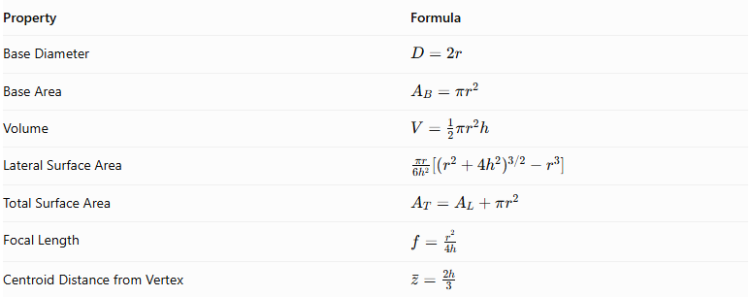
Property | Formula
Base Diameter | $$D=2r$$
Base Area | $$A_{B}=πr^{2}$$
Volume | $$V=\frac{1}{2}πr^{2}h$$
Lateral Surface Area | $$\frac{πr}{6h^{2}}[(r^{2}+4h^{2})^{3/2}-r^{3}]$$
Total Surface Area | $$A_{T}=A_{L}+πr^{2}$$
Focal Length | $$f=\frac{r^{2}}{4h}$$
Centroid Distance from Vertex | $$barz=\frac{2h}{3}$$
The centroid formula applies to a uniform solid paraboloidal segment.

Cross-Sections
# Source: AI Source: Provided by: [Data Path: Persons Table -> ID Column: 1, Name_En Column: Motasem Essam] -> From: [ChatGPT] on [7/25/2026]
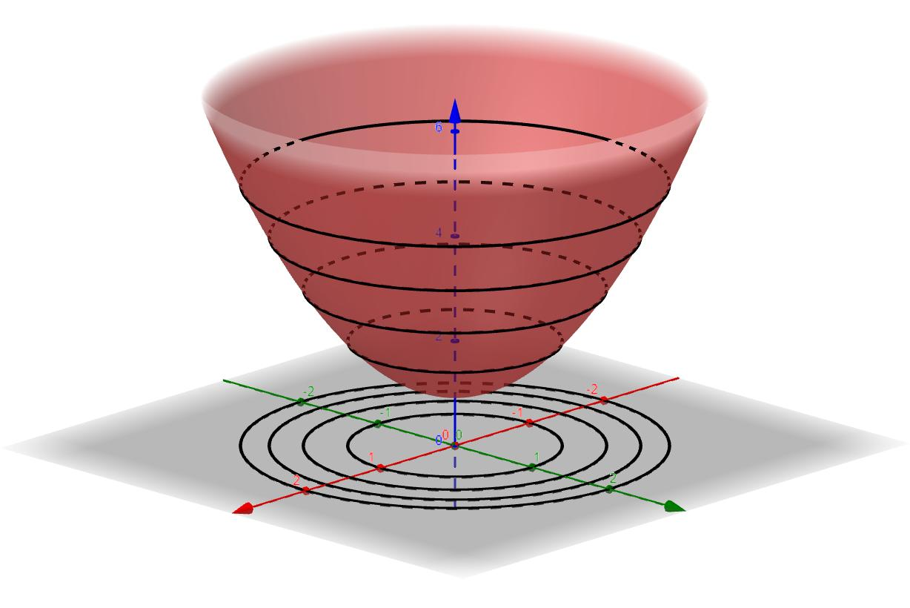
A paraboloidal solid produces different cross-sections depending on the cutting plane.
- Axial Cross-Section: A vertical plane passing through the axis produces a parabolic cross-section.
- Circular Cross-Section: A plane perpendicular to the axis produces a circle.
- Base Cross-Section: The plane bounding the finite segment produces a circle of radius $r$.
- Parallel Circular Cross-Section: At a height $z$ above the vertex, the radius is:
$$ρ(z)=r\sqrt{\frac{z}{h}}$$
The area of that cross-section is:
$$A(z)=πr^{2}\frac{z}{h}$$

Applications
# Source: AI Source: Provided by: [Data Path: Persons Table -> ID Column: 1, Name_En Column: Motasem Essam] -> From: [ChatGPT] on [7/25/2026]
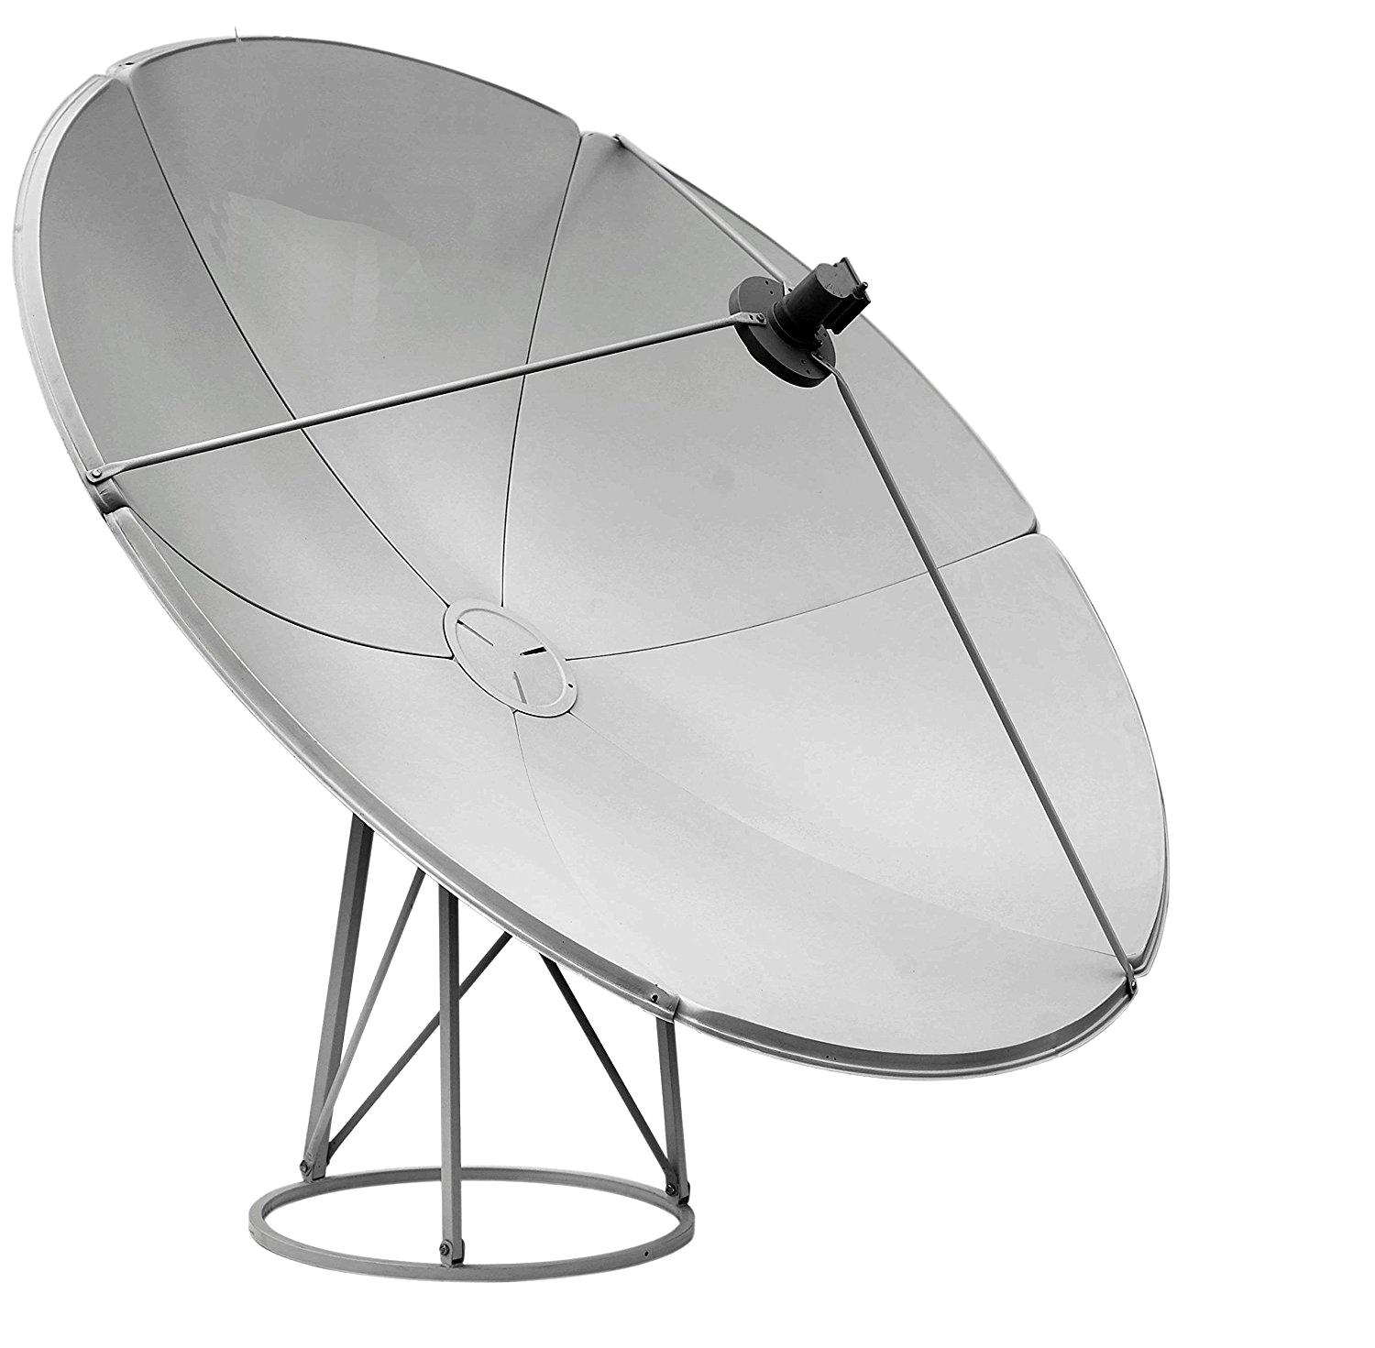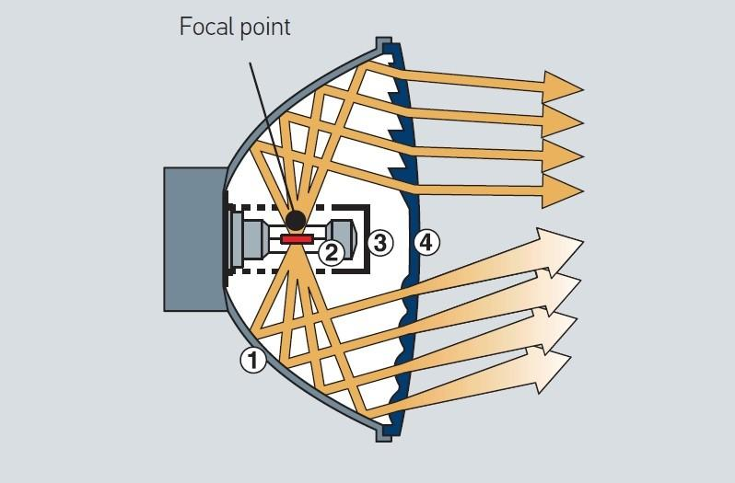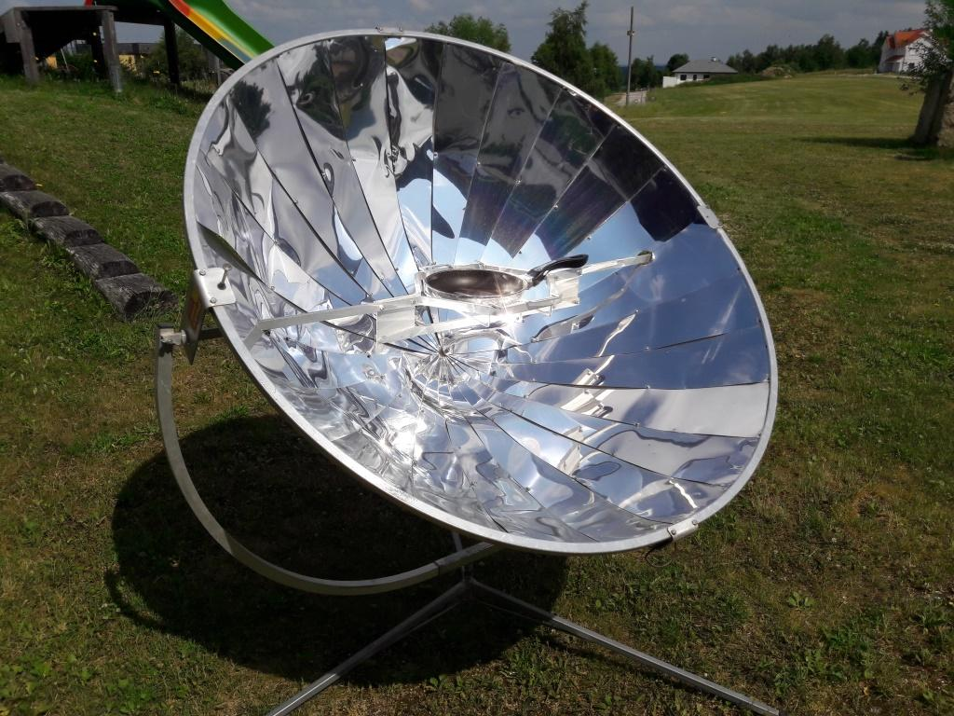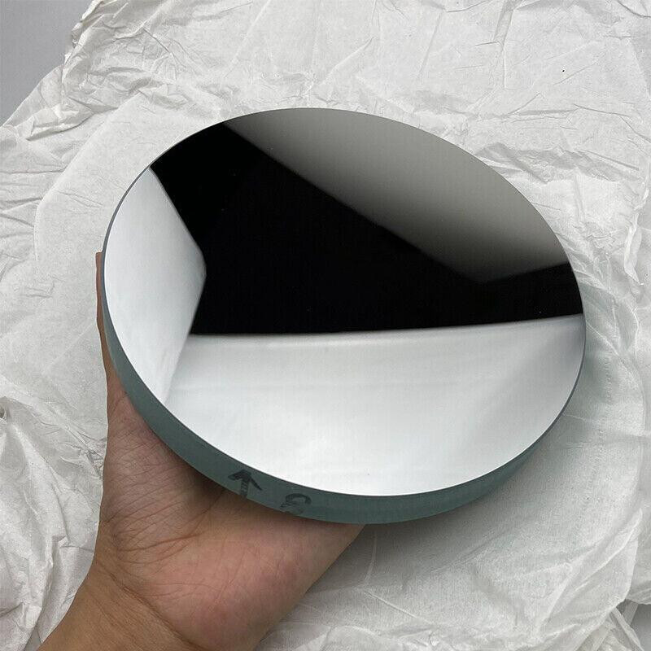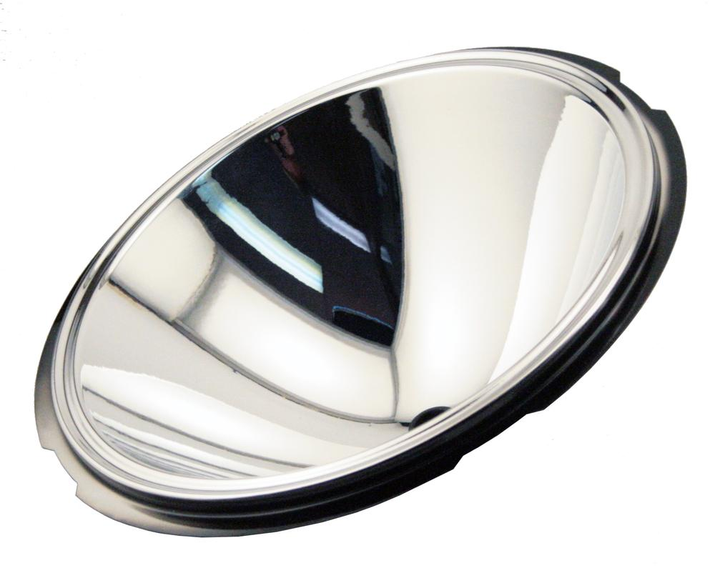
- Satellite Dishes: Paraboloidal reflectors focus incoming parallel radio waves.
- Automobile Headlights: Parabolic reflectors direct light into a controlled beam.
- Radio Telescopes: Large paraboloidal reflectors collect and focus radio signals.
- Solar Collectors: Parabolic reflectors concentrate sunlight toward a focal region.
- Engineering: Paraboloidal shapes are used in reflectors, containers, and specialized structures.
- Architecture: Paraboloidal forms are used in roofs and structural designs.

Comparison with Other Solids of Revolution
# Source: AI Source: Provided by: [Data Path: Persons Table -> ID Column: 1, Name_En Column: Motasem Essam] -> From: [ChatGPT] on [7/25/2026]
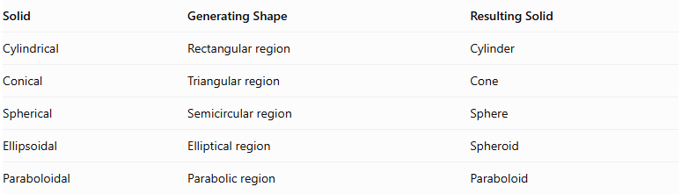
Solid | Generating Shape | Resulting Solid
Cylindrical | Rectangular region | Cylinder
Conical | Triangular region | Cone
Spherical | Semicircular region | Sphere
Ellipsoidal | Elliptical region | Spheroid
Paraboloidal | Parabolic region | Paraboloid
Important distinction: A circular paraboloid is an elliptic paraboloid with equal horizontal dimensions. A hyperbolic paraboloid is a different surface and is not a solid of revolution generated by rotating a parabola around its axis.

Main Classification
# Source: AI Source: Provided by: [Data Path: Persons Table -> ID Column: 1, Name_En Column: Motasem Essam] -> From: [ChatGPT] on [7/25/2026]
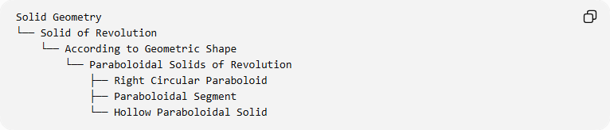
Solid Geometry
└── Solid of Revolution
└── According to Geometric Shape
└── Paraboloidal Solids of Revolution
├── Right Circular Paraboloid
├── Paraboloidal Segment
└── Hollow Paraboloidal Solid

Key Points
# Source: AI Source: Provided by: [Data Path: Persons Table -> ID Column: 1, Name_En Column: Motasem Essam] -> From: [ChatGPT] on [7/25/2026]
- A paraboloidal solid of revolution is generated by rotating a parabolic region around its axis of symmetry.
- Its curved boundary is called a paraboloidal surface.
- Its perpendicular cross-sections are circles.
- Its axial cross-sections are parabolas.
- A finite paraboloidal segment has a circular base.
- Its volume is half the volume of a cylinder with the same base and height.
- A hollow paraboloidal solid is a shell construction with inner and outer surfaces.
- A circular paraboloid is also called a paraboloid of revolution.

Conclusion
# Source: AI Source: Provided by: [Data Path: Persons Table -> ID Column: 1, Name_En Column: Motasem Essam] -> From: [ChatGPT] on [7/25/2026]
Paraboloidal solids of revolution are three-dimensional solids generated by rotating parabolic regions around their axes of symmetry. Their principal geometric form is the circular paraboloid, which has a characteristic curved surface, circular cross-sections, and a volume equal to half that of an equivalent cylinder.

